Install Moba extrem ssh client software

Link- <https://mobaxterm.mobatek.net/download-home-edition.html>

Download extract and install

Open the application.

This application is used in real tome to have multiple ssh connection on different server.

This provides flexibility to rename the session have user defined color for the session that helps a lot to improve to confession to run different commands on different servers at the same time.

Another advantage of it is that, it’s works GUI based. Once to provide details for the server such as server IP, username and password/key location. It remembers that. And the next time we are connecting to the server it will run the command automatically from backend. We can avoid to write connection command for all time “ssh -i key-location username@serverIP”.

To connect to

If want to rename the session.

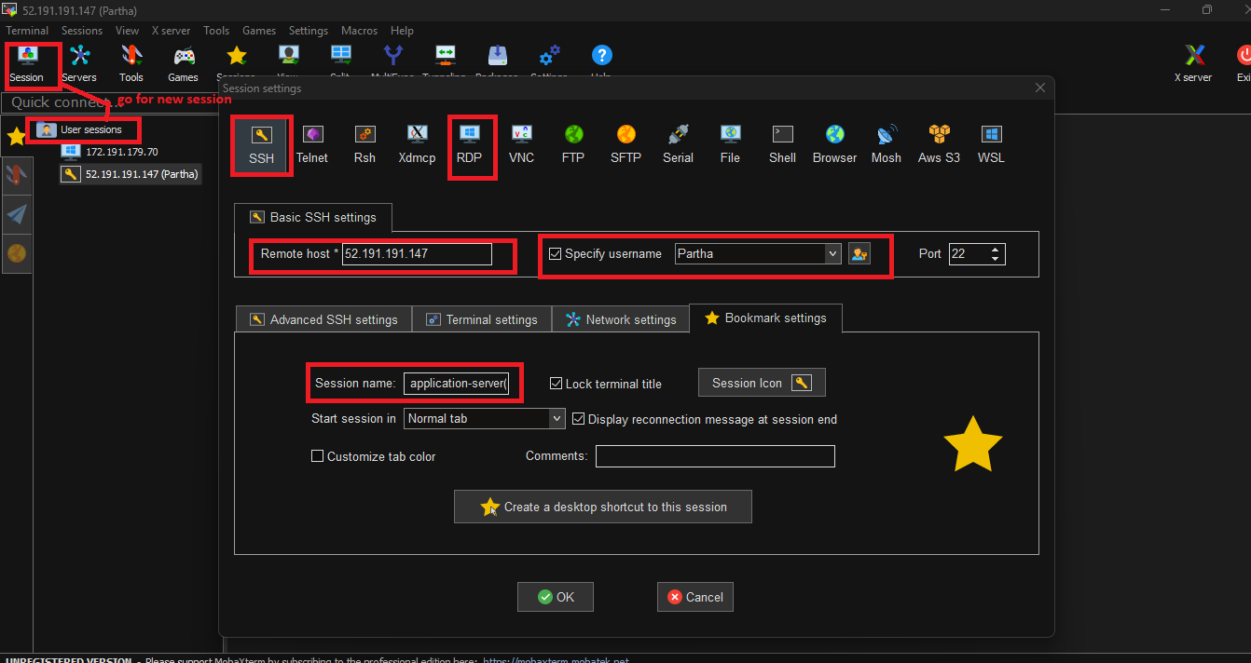

If other server have the same key/ password, user name we can duplicate and change the IP to connect to another server.

Install Prometheus (follow github documents - <https://github.com/Parthasarathi-P/Devops/blob/main/Stories%203%20Infra%20metrics%20-%20Node%20Exporter%20-%20Prometheus%20-%20Grafana.pdf>)

sudo apt update -y && sudo apt upgrade -y

7 clear

8 sudo wget https://github.com/prometheus/prometheus/releases/down

9 sudo groupadd --system prometheus

10 sudo useradd -s /sbin/nologin --system -g prometheus prometheus

11 sudo mkdir /var/lib/prometheus

12 sudo mkdir -p /etc/prometheus/rules

13 sudo mkdir -p /etc/prometheus/rules.s

14 sudo mkdir -p /etc/prometheus/files_sd

15 sudo wget https://github.com/prometheus/prometheus/releases/download/v3.2.1/prometheus-3.2.1.darwin-arm64.tar.gz

16 sudo groupadd --system prometheus

17 sudo useradd -s /sbin/nologin --system -g prometheus prometheus

18 sudo mkdir /var/lib/prometheus

19 sudo mkdir -p /etc/prometheus/rules

20 sudo mkdir -p /etc/prometheus/rules.s

21 sudo mkdir -p /etc/prometheus/files_sd

22 ls

23 sudo tar xvf prometheus-3.2.1.darwin-arm64.tar.gz

24 clear

25 ls

26 cd prometheus-3.2.1.darwin-arm64

27 sudo mv prometheus promtool /usr/local/bin/

28 sudo mv prometheus.yml /etc/prometheus/prometheus.yml

29 sudo tee /etc/systemd/system/prometheus.service<<EOF

[Unit]

Description=Prometheus

Documentation=https://prometheus.io/docs/introduction/overview/

Wants=network-online.target

After=network-online.target

[Service]

Type=simple

User=prometheus

Group=prometheus

ExecReload=/bin/kill -HUP $MAINPID

ExecStart=/usr/local/bin/prometheus --config.file=/etc/prometheus/prometheus.yml --storage.tsdb.path=/var/lib/prometheus --web.console.templates=/etc/prometheus/consoles --web.console.libraries=/etc/prometheus/console_libraries --web.listen-address=0.0.0.0:9090 --web.external-url=

SyslogIdentifier=prometheus

Restart=always

[Install]

WantedBy=multi-user.target

EOF

46 sudo chown -R prometheus:prometheus /etc/prometheus

47 sudo chown -R prometheus:prometheus /etc/prometheus/*

48 sudo chmod -R 775 /etc/prometheus

49 sudo chmod -R 755 /etc/prometheus/*

50 sudo chown -R prometheus:prometheus /var/lib/prometheus/

51 sudo chown -R prometheus:prometheus /var/lib/prometheus/*

52 sudo systemctl daemon-reload

53 sudo systemctl start prometheus

54 sudo systemctl enable prometheus

Issue – Prometheus service is not running it goes to failed state.

Reason for the error-

It looks like you downloaded the **Darwin (macOS) ARM64** version of Prometheus (prometheus-3.2.1.darwin-arm64.tar.gz) and tried running it on a Linux system. That’s why you’re getting the **Exec format error**—it’s an incompatible binary.

To completely remove Prometheus from your system and do a clean reinstallation, follow these steps:

**Step 1: Stop and Disable Prometheus**

bash

CopyEdit

sudo systemctl stop prometheus

sudo systemctl disable prometheus

**Step 2: Remove Prometheus Binary and Configuration Files**

bash

CopyEdit

sudo rm -rf /usr/local/bin/prometheus

sudo rm -rf /usr/local/bin/promtool

sudo rm -rf /etc/prometheus

sudo rm -rf /var/lib/prometheus

**Step 3: Remove Prometheus System User and Group**

bash

CopyEdit

sudo userdel -r prometheus

sudo groupdel prometheus

**Step 4: Remove Systemd Service File**

bash

CopyEdit

sudo rm -f /etc/systemd/system/prometheus.service

Then reload systemd:

bash

CopyEdit

sudo systemctl daemon-reload

**Step 5: Verify Removal**

Check if Prometheus is completely removed:

bash

CopyEdit

which prometheus # Should return nothing

systemctl status prometheus # Should say "Unit prometheus.service could not be found"

Correct command to install Prometheus

92. sudo apt update

93 wget https://github.com/prometheus/prometheus/releases/download/v2.45.0-rc.0/prometheus-2.45.0-rc.0.linux-amd64.tar.gz

94 sudo groupadd --system prometheus

95 sudo useradd -s /sbin/nologin --system -g prometheus prometheus

96 sudo mkdir /var/lib/prometheus

97 sudo mkdir -p /etc/prometheus/rules

98 sudo mkdir -p /etc/prometheus/rules.s

99 sudo mkdir -p /etc/prometheus/files_sd

100 sudo tar xvf prometheus-2.45.0-rc.0.linux-amd64.tar.gz

101 cd prometheus-2.45.0-rc.0.linux-amd64

102 sudo mv prometheus promtool /usr/local/bin/

103 sudo mv prometheus.yml /etc/prometheus/prometheus.yml

104 sudo tee /etc/systemd/system/prometheus.service<<EOF

[Unit]

Description=Prometheus

Documentation=https://prometheus.io/docs/introduction/overview/

Wants=network-online.target

After=network-online.target

[Service]

Type=simple

User=prometheus

Group=prometheus

ExecReload=/bin/kill -HUP $MAINPID

ExecStart=/usr/local/bin/prometheus --config.file=/etc/prometheus/prometheus.yml --storage.tsdb.path=/var/lib/prometheus --web.console.templates=/etc/prometheus/consoles --web.console.libraries=/etc/prometheus/console_libraries --web.listen-address=0.0.0.0:9090 --web.external-url=

SyslogIdentifier=prometheus

Restart=always

[Install]

WantedBy=multi-user.target

EOF

105 sudo chown -R prometheus:prometheus /etc/prometheus

106 sudo chown -R prometheus:prometheus /etc/prometheus/*

107 sudo chmod -R 775 /etc/prometheus

108 sudo chmod -R 755 /etc/prometheus/*

109 sudo chown -R prometheus:prometheus /var/lib/prometheus/

110 sudo chown -R prometheus:prometheus /var/lib/prometheus/*

111 sudo systemctl daemon-reload

112 sudo systemctl start prometheus

113 sudo systemctl enable prometheus

114 sudo mkdir -p /var/lib/prometheus

115 sudo chown -R prometheus:prometheus /var/lib/prometheus

116 sudo chmod -R 775 /var/lib/prometheus

117 sudo chown -R prometheus:prometheus /var/lib/prometheus/*

118 sudo systemctl daemon-reload

119 sudo systemctl start prometheus

120 sudo systemctl enable prometheus

121 systemctl status prometheus

Now get the Prometheus on browser by IP and port.

Prometheus runs on default port 9090 make sure port is allowed on NSG.

To get public IP of the server using cmd.

>> 40.91.67.70



Once we are done with setup on Prometheus. We need to install node exporter on working nodes. Prometheus acts like the centralized server for collected Metrix data, it collects data from all servers and stores to it’s database.

We can analyze the data by using PROMql or we can integrate with Grafana server to have Grafana dashboard.

Install node exporter to servers, those acts like agent to collect data and send to Prometheus server.

Official document-

[Download | Prometheus](https://prometheus.io/download/#node_exporter)

Follow document to install.

Note- make sure you are installing this on correct severs, ie. The servers you want to monitor.

>>

sudo wget <https://github.com/prometheus/node_exporter/releases/download/v1.9.0/node_exporter-1.9.0.linux-amd64.tar.gz>

commad to install node exporter

sudo wget https://github.com/prometheus/node_exporter/releases/download/v1.9.0/node_exporter-1.9.0.linux-amd64.tar.gz

7 ls

8 sudo groupadd --system prometheus

9 sudo useradd -s /sbin/nologin --system -g prometheus prometheus

10 sudo mkdir /var/lib/node

11 sudo tar xvf node_exporter-1.9.0.linux-amd64.tar.gz

12 cd node_exporter-1.6.0.linux-amd64

13 ls

14 cd node_exporter-1.9.0.linux-amd64

15 sudo mv node_exporter /var/lib/node

16 sudo tee /etc/systemd/system/node.service<<EOF

[Unit]

Description=Prometheus Node Exporter

Documentation=https://prometheus.io/docs/introduction/overview/

Wants=network-online.target

After=network-online.target

[Service]

Type=simple

User=prometheus

Group=prometheus

ExecReload=/bin/kill -HUP $MAINPID

ExecStart=/var/lib/node/node_exporter

SyslogIdentifier=prometheus_node_exporter

Restart=always

[Install]

WantedBy=multi-user.target

EOF

17 vi script.sh

18 cd ~

19 vi script.sh

20 cat script.sh

21 sudo chmod 777 script.sh

22 ls

23 sudo ./script.sh

24 systemctl status nodeexporter

25 systemctl status node

Node exporter runs on default port 9100.

Check it.

On metrices we can see what all metrices will be captured.

To see targets from Prometheus

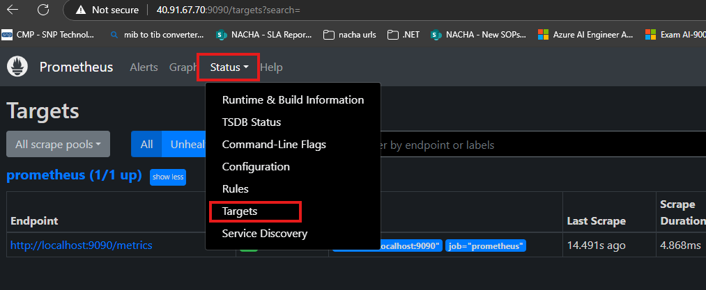

Once the node exporter installation is done, we need to set up the server to Prometheus for monitoring.

Go to the server where Prometheus is installed and configure the monitoring server on yaml file.

Go to Prometheus server.

>> sudo vi /etc/prometheus/prometheus.yml

Edit the file and provide the server details need to monitor

Ex-

# my global config

global:

scrape_interval: 15s # Set the scrape interval to every 15 seconds. Default is every 1 minute.

evaluation_interval: 15s # Evaluate rules every 15 seconds. The default is every 1 minute.

# scrape_timeout is set to the global default (10s).

# Alertmanager configuration

alerting:

alertmanagers:

- static_configs:

- targets:

# - alertmanager:9093

# Load rules once and periodically evaluate them according to the global 'evaluation_interval'.

rule_files:

# - "first_rules.yml"

# - "second_rules.yml"

# A scrape configuration containing exactly one endpoint to scrape:

# Here it's Prometheus itself.

scrape_configs:

# The job name is added as a label `job=<job_name>` to any timeseries scraped from this config.

- job_name: "prometheus"

# metrics_path defaults to '/metrics'

# scheme defaults to 'http'.

static_configs:

- targets: ["localhost:9090"]

- job_name: "server1"

static_configs:

- targets: ["52.191.191.147:9100"]

How many servers those many job will be added. In job section provide server details need to monitor.

Provide unique job name for identifying server,

Save the file 🡪 restart Prometheus service.

>> sudo systemctl restart Prometheus

If want to validate the Prometheus configuration.

>> promtool check config /etc/prometheus/prometheus.yml

To check Prometheus service tergets from the cmd itself.

>> curl -s http://localhost:9090/api/v1/status/config | grep targets

Verify the metrices are getting properly

>> curl -v <http://52.191.191.147:9100/metrics>

If want to verify the targeted servers status from cmd

>> sudo apt update && sudo snap install jq

>> curl -s http://localhost:9090/api/v1/targets | jq .data.activeTargets

To see error logs on Prometheus

>> journalctl -u prometheus.service -b --no-pager | tail -50

Go to Prometheus browser and navigate to targets page.

Make sure no filter applied else it might not show all servers.

Go to graph and write query to get results.

Note- if you want result as table format keep table else go to graph.

Graph

>> up{job="server1"}

Table-

Few more queries-

>> node_cpu_seconds_total

>> node_memory_MemAvailable_bytes

The metrices name we can get from node exporter metrices.

Now Go ahead to setup Grafana for easy monitoring and graphical representation.